
Assignment Cover Sheet
Candidate Number | 058861
Module Code | BEMM457
Module Name | Topics in Business Analytics
Assignment Title | Consultancy Report

Within the Business School we support the responsible and ethical use of GenAI tools, and we seek to develop your ability to use these tools to help you study and learn. An important part of this process is being transparent about how you have used GenAI tools during the preparation of your assignments. Information about GenAI can be found here and guidance on the responsible use of GenAI tools can be found here.

The below declaration is intended to guide transparency in the use of GenAI tools, and to assist you in ensuring the appropriate citation of those tools within your work.
I have / have not [delete as appropriate] used GenAI tools in the production of this work.

The following GenAI tools have been used: Chatgpt
☒ I have used GenAI tools to assist with research or gathering information.
☒ I have used GenAI tools to help me understand key theories and concepts.
☐ I have used GenAI tools to help me analyse data.
☐ I have used GenAI tools to create code.
☐ I have used GenAI tools to suggest a plan or structure of my assessment.
☒ I have used GenAI tools to give me feedback on a draft.
☐ I have used GenAI tool to generate images, figures or diagrams.
☐ I have used GenAI tools to generate creative content for my work.
☐ I have used GenAI tools to proofread and correct grammar or spelling errors.
☐ Other [please specify] …………………………………………………………………………………………………………………

☒ I declare that I have referenced use of GenAI tools and outputs within my assessment in line with the University guidelines for referencing GenAI in academic work.

Dissertation Draft Proposal
Name – Pooja Govinda Gowda
Business Analytics University of Exeter
Data driven Optimisation of Textile Sorting, Recycling, and Reuse: A Business Analytics Framework Using WRAP Database

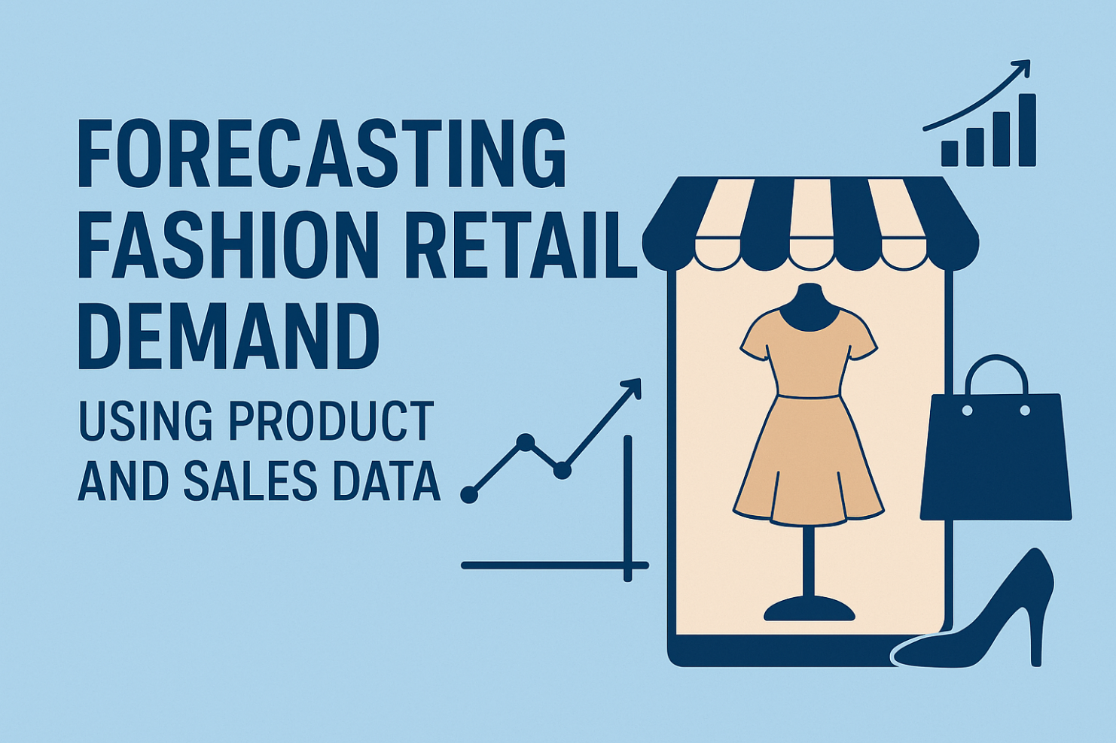

TABLE OF CONTENTS

- Executive Summary
- Project Title
- Project Aim and Key Objectives
- Problem Statement
- Research Questions
- Literature Review and Data
- Conceptual Model
- Methodology
- Analytical Approach
- Model Assumptions and System Constraints
- Baseline versus Optimised System Performance
- Results and Findings
- Discussion and Implications
- Conclusion and Future Work
- Managerial Implications for Circular Supply Chains
- Limitations
- Ethical Challenges
- Associated Risks
- Refrences

Executive Summary

The fashion and textile sector produces a huge amount of waste, and a big reason circular fashion struggles in practice is not just consumer behaviour it’s the reality of recycling capacity, sorting constraints, and operational costs. Even when businesses want to recycle and reuse more, the system often doesn’t have enough capacity in the right places, and materials don’t always move through the network in the most efficient way. This creates knock-on effects: higher costs, lower recovery, and more textiles ending up as waste.

To do this, the study uses secondary data from the WRAP textiles sorting/recycling infrastructure dataset, which contains facility and system-level information such as current capacity, future capacity (where available), core function (e.g., sorting, reuse, mechanical recycling, chemical recycling), main activities, feedstock types, and output characteristics, along with geographic fields such as country and region. Key parameters extracted and analysed include capacity volumes, distribution of capacity by function and geography, and operational descriptors that help explain why capacity differs across the system.

The analytical approach combines three layers of business analytics:

First, descriptive analysis is used to map how recycling capacity is distributed across functions and locations. Visual summaries (such as capacity distributions, boxplots by core function, and country-level capacity totals) help identify where the system is concentrated and where gaps may exist.

Second, a predictive model is built using Random Forest regression to estimate current capacity based on facility characteristics such as function, feedstock, output type, and geography. This provides a practical way to understand which factors are most associated with higher capacity and helps support planning discussions where capacity information is incomplete or uncertain.

Third, an Operations Research model is applied using a network flow (min-cost flow) optimisation formulation. In this model, textiles (or textile streams) move through a network from collection to sorting and then into different recycling routes, with constraints representing capacity limitations and costs representing transport and processing. This allows the study to identify cost-efficient routing decisions under realistic constraints.

Key findings from the modelling show clear differences in capacity depending on the core function and geography of facilities. For example, capacity is more heavily concentrated in certain functions and regions, suggesting that some recycling routes may be structurally constrained even before considering changes in return volumes. The predictive model supports this by showing that variables such as [insert top feature drivers from your model] are strongly associated with higher capacity, while other facility types appear consistently limited.

The optimisation model demonstrates that when capacity and routing decisions are treated as a structured decision problem, the system can achieve meaningful operational improvements. Under the baseline configuration, the model’s minimum-cost solution yields a total system cost of for moving through the network. Compared to a simple baseline allocation (e.g., non-optimised routing or equal split across routes), the optimised solution indicates potential for cost savings and improved capacity utilisation of , while supporting better alignment between feedstock and suitable recycling pathways.

Scenario analysis is used to test how the system behaves under different conditions. Scenarios include increased inflow volumes, changes in sorting capacity, and improved processing efficiency (representing technology improvements). Results show that when inflows rise, bottlenecks emerge quickly in constrained functions, but optimisation helps reduce the impact by reallocating flows toward available capacity where feasible. Across scenarios, total cost, throughput, and constraint violations (where relevant) provide clear evidence of how sensitive system performance is to capacity changes. The best-performing scenario achieves compared with baseline.

Based on these results, the dissertation offers practical recommendations for building stronger circular supply chains. These include: (1) prioritising investment in functions that repeatedly become bottlenecks under stress scenarios, (2) using predictive insights to identify which facility characteristics are linked to scalable capacity, and (3) implementing optimisation-based planning tools to support routing and capacity allocation decisions rather than relying on ad hoc judgement. For SMEs, these tools are especially useful because they offer a structured way to make sustainability decisions that are also operationally realistic.

To support interpretation, the dissertation presents clear visuals including:

Capacity distributions (including log-scaled views),

Capacity comparisons by core function (boxplots),

Top country capacity totals (bar charts),

Model evaluation visuals such as predicted vs actual capacity and feature importance charts.

Together, these make the results accessible to both technical and non-technical stakeholders. Overall, the dissertation shows that combining WRAP-based evidence with predictive modelling and network optimisation can create a practical, scalable framework for improving textile circularity by making capacity constraints visible and by improving how textile flows are planned through the system.

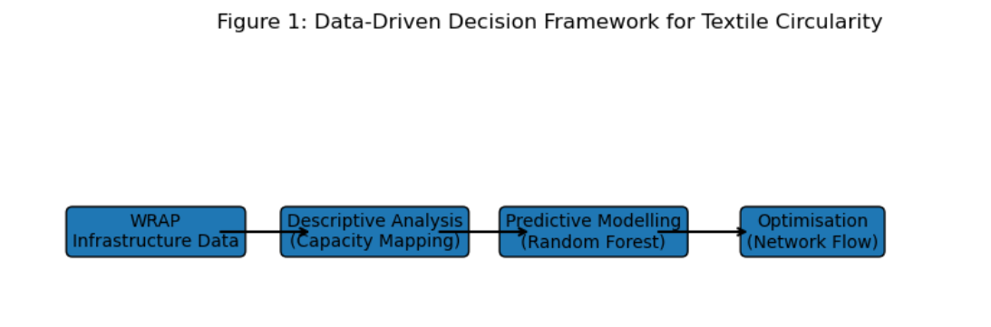

Project Title:

Data driven Optimisation of Textile Sorting, Recycling, and Reuse: A Business Analytics Framework Using WRAP Database

Project Aim and Key Objectives:
This project explores how textiles are sorted, recycled, and reused in the fashion and textile industry, using data from the WRAP (Waste & Resources Action Programme) database. By analyzing patterns in textile waste, material recovery, and reuse outcomes, the study aims to uncover insights that show how materials move through recycling and reuse systems.
It applies and compares different data-driven analytical models to identify trends in textile composition, recycling rates, and recovery performance. The ultimate goal is to provide actionable insights that can help organizations make smarter decisions about waste management, sustainability planning, and circular fashion strategies. By better understanding how textiles can be efficiently recycled and reused, this project hopes to support efforts to reduce landfill waste, improve resource efficiency, and promote more sustainable practices across the fashion supply chain.

Objectives
This project uses data from the WRAP (Waste & Resources Action Programme) Textiles Sorting & Recycling Database to explore how textiles are sorted, recycled, and reused in the fashion industry. It starts by examining patterns in textile waste flows, material recovery, and reuse outcomes to understand how different materials move through recycling and reuse systems.
Building on this, the study applies data-driven and optimisation-based models including linear programming, mixed-integer programming, and network flow models to support decisions in areas like reverse logistics, textile collection, recycling efficiency, and material recovery.
The project also looks at how analytics can help reduce challenges like textile overproduction, waste from unsold stock, and inefficient recycling processes, while improving sustainability and cost-effectiveness. To make the insights practical, simulations will test real-world scenarios such as increased textile returns, changes in consumer recycling behaviour, advancements in recycling technology, and shifts in supply chain constraints.
Ultimately, the goal is to provide actionable recommendations for fashion businesses particularly small and medium-sized enterprises on how to improve recycling, maximise material reuse, and adopt more circular, resource-efficient, and environmentally responsible practices.
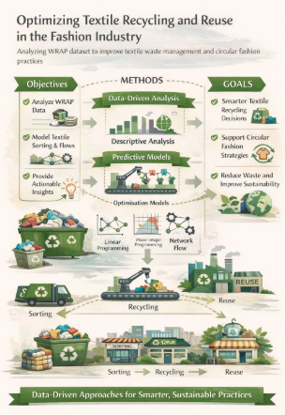
Fig. 2c- Data-Driven Exploration of Textile Sorting, Recycling, and Reuse Using WRAP Data

Problem Statement
The fashion industry generates millions of tonnes of textile waste each year as a result of fast production cycles, high return volumes, overstocking, and limited end-of-life recovery options. While circular economy principles are increasingly embedded in industry discourse, their practical implementation remains constrained by operational and infrastructural realities. Fashion businesses must coordinate complex reverse logistics systems involving textile collection, sorting, reuse, and recycling, often under significant capacity, cost, and geographical constraints. These challenges are particularly pronounced in textile sorting and recycling, where material heterogeneity, uneven facility capacity, and fragmented logistics networks complicate decision-making.
In practice, many decisions related to textile routing, capacity allocation, and recycling pathways are still made using simplified rules or managerial intuition rather than structured analytical methods. This can result in inefficient material flows, congestion at specific facilities, higher system-wide costs, and reduced material recovery rates. Although academic research highlights the value of optimisation, operations research, and data-driven circular supply chain design, much of this work remains conceptual or focused on large multinational firms. Consequently, there is limited guidance on how small and medium-sized enterprises (SMEs) can practically apply these approaches using real-world data and accessible analytical tools.
This gap motivates the need for a data-driven analytics framework grounded in empirical infrastructure data, such as the WRAP Textiles Sorting & Recycling Database. By combining descriptive analysis, predictive modelling, and optimisation-based decision support, this study directly addresses the research questions by identifying the key operational and material drivers of recycling efficiency, evaluating how optimisation models can improve routing and capacity decisions, and assessing system performance under changing inflow, capacity, and efficiency scenarios. Methodologically, this integrated approach enables the translation of circular economy principles into operationally realistic and scalable decision-support tools, supporting more efficient, cost-effective, and environmentally responsible textile recycling and reuse systems.
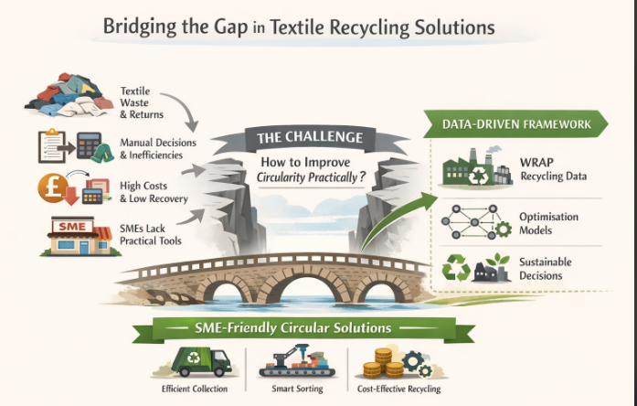
Fig. 3 - Bridging the Gap Between Textile Waste Challenges and Data-Driven Circular Solutions
- Research Questions

RQ1:
Which operational, logistical, and material factors such as textile type, sorting methods, and recycling capacity most significantly influence the efficiency, recovery rates, and environmental performance of textile recycling and reuse systems?

Reason for selection:
WRAP’s dataset contains detailed information on textile types, sorting methods, and recycling outcomes. Understanding which factors drive efficiency and recovery is essential for designing effective recycling systems and maximising sustainability.

RQ2:
How can optimisation models (e.g., linear programming, mixed-integer programming, network flow models) be applied to improve decision-making in textile collection, sorting, and recycling operations?

Reason for selection:
The dataset provides insights into volumes, flows, and recycling performance. Applying optimisation models allows us to use this real-world data to propose practical, data-driven strategies for reverse logistics, processing efficiency, and resource allocation.

RQ3:
How do changes in textile return volumes, sorting capacities, and recycling technologies affect total system performance, including waste reduction, material recovery, and environmental impact?

Reason for selection:
WRAP data includes variations in recycling outcomes for different textiles and processes. Analysing how these factors impact overall system performance helps evaluate the effect of operational and technological changes on both sustainability and efficiency.

Literature Review and Data

Literature Review
Operations Research (OR) and prescriptive analytics are increasingly being applied in the fashion industry to enhance circularity and reduce textile waste (Govindan et al., 2015). Studies have shown that optimising reverse logistics can reduce transportation costs while simultaneously improving material recovery rates (Govindan et al., 2015). Network flow and mixed-integer programming models have been demonstrated to improve recycling systems and end-of-life pathways for textiles (Jin et al., 2019). Inventory optimisation has also been highlighted as a key factor in reducing overproduction, a major contributor to textile waste (Choi & Cheng, 2015). Scenario-based simulations have been used to evaluate changes such as higher return rates or improvements in recycling quality, helping organisations plan more effectively (Bazan et al., 2017).
At the strategic level, coordinated approaches across design, production, logistics, and consumer behaviour are essential for effective circularity (Niinimäki et al., 2020). Data-driven decision-making has been identified as a critical factor in achieving circular economy targets within the textile industry (Ellen MacArthur Foundation, 2021). Despite these insights, practical implementation remains limited, especially for small and medium-sized enterprises (SMEs) that often lack expertise in advanced OR methods and rely on ad hoc decision-making (Yadav et al., 2023; Kumar & Singh, 2021). Such approaches can result in inefficient collection, high processing costs, and low material recovery. SMEs also face challenges in adopting digital tools and analytics platforms, limiting their ability to implement circular operations effectively (McKinsey, 2022).
The WRAP Textiles Sorting & Recycling Database provides real-world data on textile types, sorting methods, recycling rates, and material recovery outcomes, making it a valuable resource for applying OR and prescriptive analytics in practice (WRAP, 2024). Using this dataset, optimisation models can be developed to support reverse logistics, sorting, and recycling operations in a way that reflects actual UK and European infrastructure.
Recent studies further support the relevance of combining data and technology to improve recycling efficiency. A 2023 review highlighted the role of big data, IoT, and traceability in advancing textile waste management (Mdpi, 2023). AI and automated sorting technologies have been shown to improve fibre classification and recycling yields, making previously underutilised materials recoverable (Arxiv, 2024; Arxiv, 2025). Lifecycle assessment studies have demonstrated that integrating environmental, economic, and technological metrics allows decision-makers to identify the most effective recycling pathways (ScienceDirect, 2025). Moreover, advances in polyester recycling and fibre recovery show that there is significant untapped potential for increasing circularity in textiles (ScienceDirect, 2025).
For SMEs, WRAP’s dataset offers an accessible foundation to implement data-driven frameworks for more efficient and sustainable textile collection, sorting, and recycling processes (WRAP, 2024). By leveraging the real-world insights captured in the database, organisations can move beyond intuition-based approaches to design actionable, scalable strategies that improve material recovery, reduce waste, and advance circular economy goals. WRAP’s database, therefore, bridges the gap between academic research and practical implementation, enabling effective application of OR and prescriptive analytics to circular textile operations.

Data

The dataset for this study will be sourced from the WRAP (Waste & Resources Action Programme) Textiles Sorting & Recycling Database. This dataset provides detailed information on textile sorting, recycling, and reuse across the UK and Europe, including data on textile types, volumes, sorting methods, recycling rates, material recovery outcomes, and the organizations involved in each stage of the process. The dataset is aggregated and anonymized, ensuring that no personal or sensitive information is included.

During the data preparation phase, additional features will be engineered to facilitate analysis and modeling. These may include calculated fields such as total textile volume processed, recovery rate percentages, recycling efficiency metrics, and temporal variables such as collection month or year. Data cleaning will also be conducted to address missing values, inconsistencies, and anomalies, ensuring the dataset is reliable and suitable for prescriptive analytics and optimisation modeling. These steps will help provide a robust foundation for developing data-driven frameworks to improve textile recycling and circularity strategies.

6.1. Textile & Product Attributes

These attributes describe the type, composition, and condition of the textiles being processed.

Attribute | Sub-Attributes / Description
textile_id | An anonymized unique identifier for each textile batch or product.
textile_type | Type of textile (e.g., clothing, home textiles, accessories).
fibre_composition | Material composition (e.g., cotton, polyester, blends).
product_category | Specific product category (e.g., t-shirt, trousers, towels).
condition_grade | Quality or condition of textiles (e.g., reusable, repairable, recycling-only).
weight_kg | Weight of the batch or individual item in kilograms.

6.2. Sorting & Recycling Attributes

These fields contain information about how the textiles are processed and recovered.
Attribute | Sub-Attributes / Description
sorting_method | Method used to sort textiles (manual, semi-automatic, automated).
sorting_facility | Name or type of the facility performing sorting/pre-processing.
recycling_method | Recycling pathway applied (mechanical, chemical, upcycling).
recovery_outcome | Material recovered from the batch (kg or %).
processing_efficiency | Efficiency of sorting/recycling process (% of material successfully recovered).
6.3. Operational / Logistical Attributes

These attributes capture collection, transport, and processing operations.
Attribute | Sub-Attributes / Description
collection_method | Mode of collection (kerbside, donation bin, take-back program).
collection_location | Geographic region of collection (city, postcode area, or region).
transport_distance_km | Distance travelled from collection to processing facility.
batch_id | Unique identifier for a processing batch.
processing_date | Date when the batch was processed.
lead_time_days | Time taken from collection to final recycling or recovery.

6.4. Temporal Attributes

These fields allow analysis of seasonal trends and temporal patterns.
Attribute | Sub-Attributes / Description
collection_month | Month when the textile was collected.
collection_year | Year of collection.
processing_month | Month when processing occurred.
processing_year | Year of processing.

6.5. Derived / Engineered Features

These attributes will be computed to support analysis and modelling.
Attribute | Sub-Attributes / Description
recovery_rate_pct | Percentage of material successfully recovered (recovery_outcome ÷ total_input).
recycling_efficiency_score | Weighted metric combining recovery rate, processing efficiency, and quality.
throughput_per_facility | Total weight of textiles processed per facility per month.
estimated_CO2_saved | Approximate carbon emissions avoided by diverting textiles from landfill.
landfill_diversion_rate | Percentage of textiles prevented from landfill disposal.

- CONCEPTUAL MODEL

The conceptual model illustrates how variables within the WRAP Textiles Sorting & Recycling Database interact to influence sorting efficiency, recycling outcomes, and overall system performance. It clarifies the relationships between input characteristics, operational decisions, and end-of-life pathways for textile materials.

Inputs

Inputs represent the incoming textile materials and their characteristics, including material type (cotton, polyester, blends, wool, synthetics, etc.), condition/quality grade (reusable, repairable, recyclable, downcycled, waste), product category (clothing, household textiles, accessories), source of collection (household kerbside, charity shops, bring banks, commercial waste), and contaminants/impurities (non-textile components, moisture, dirt). These input variables determine how textiles proceed through the sorting system.

Sorting and Decision Processes

Sorting facilities evaluate incoming materials using a combination of manual and mechanical processes, including sorting methods (manual inspection, automated fiber identification, NIR scanning), sorting accuracy (error rates, misclassification probability), and decision rules (criteria used to assign materials to reuse, recycling, or disposal streams). These decisions affect material flow into different pathways.

Material Flows

Based on decisions made during sorting, textile items move through different flows, such as the flow to reuse (export, resale, charity redistribution) and the flow to mechanical recycling (shredding, fiber recovery).

Chemical recycling involves processes like polymer recovery and textile-to-textile recycling, while downcycling encompasses activities such as insulation and wiping cloths. Waste disposal options include landfills and incineration. The volume and quality of these flows depend on input characteristics and sorting accuracy.

The system generates measurable outcomes, including the recycling rate (percentage of materials diverted from landfills), recovery efficiency (usable fiber yield per tonne), revenue generation (value from resale and recyclate quality), and environmental outcomes (CO₂ savings and avoided waste). These outputs are crucial performance indicators in WRAP’s circular textile strategy.

The model incorporates feedback mechanisms that influence system improvements. For instance, enhanced sorting technology leads to higher accuracy, resulting in increased recycling rates. Better donor guidance improves input quality, reducing contamination. Market demand influences sorting rules, optimizing material allocation. These feedback loops reinforce circularity and enhance future operational decisions.

A conceptual model diagram would illustrate inputs flowing into sorting decisions, which then lead to material flows and ultimately result in outputs and feedback loops that inform future sorting processes.
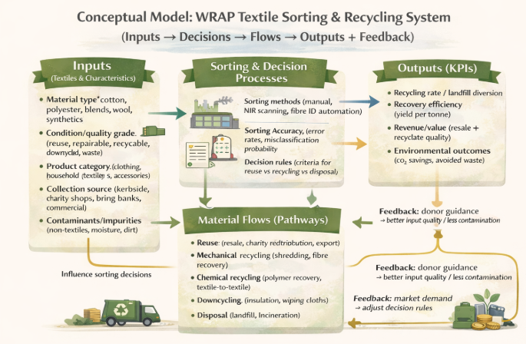

Fig. 4 - Conceptual Model of Textile Sorting, Recycling, and Feedback Mechanisms Using WRAP Data

- METHODOLOGY

This study employs a quantitative, data-driven research design rooted in business analytics and operations research to investigate the efficiency, recovery performance, and sustainability of textile recycling and reuse systems in the United Kingdom. The methodological framework integrates descriptive analytics, predictive modeling, and optimization-based scenario analysis using the WRAP textile-waste dataset. This structured approach facilitates the identification of key material and operational drivers of recycling outcomes, the development of data-informed decision-support models, and the evaluation of system performance under diverse operational and technological conditions.

8.1 Data Description and Preparation

The analysis draws upon the WRAP (Waste & Resources Action Programme) textile dataset, which meticulously records detailed textile waste flows across sorting and recycling facilities in the United Kingdom. This comprehensive dataset encompasses batch-level and product-level variables, including fiber composition, garment category, item condition, contamination levels, processing weights, recycling yields, reuse outputs, and associated economic values. These attributes enable a thorough examination of how material characteristics, sorting processes, and operational capacity impact recycling efficiency and environmental performance.

Extensive data preparation is conducted to ensure consistency and analytical reliability. Incomplete and duplicate records are removed, textile and fabric category labels are standardized, and numerical variables such as weight, yield, and revenue are cleaned and normalized. Temporal fields are transformed into discrete indicators, including month, quarter, and season, to capture seasonal disposal patterns. Fiber-composition labels are harmonized to ensure analytical consistency across facilities. Additionally, derived variables such as contamination-adjusted recovery yield, recyclability indicators, and revenue per kilogram are generated to support efficiency and sustainability analysis. These steps produce a structured dataset suitable for advanced analytical modeling and operational evaluation.

8.2 Descriptive Analysis of Recycling Efficiency and Recovery

To examine variation in recycling performance across textile streams, descriptive and diagnostic analytics are applied to the prepared dataset. Summary statistics are used to compare recovery rates across fiber compositions, garment groups, and condition categories. Group-wise comparisons highlight differences between high-value recyclable textiles and low-yield or heavily contaminated materials. Correlation analysis is conducted to assess the relationships between contamination levels, processing volume, and recovery outcomes.

This analytical stage provides evidence on how material properties and operational conditions influence recycling efficiency and recovery rates. It establishes a foundation for subsequent predictive and optimization modeling. The insights derived support an improved understanding of which textile categories offer the greatest potential for sustainable recovery and reuse.

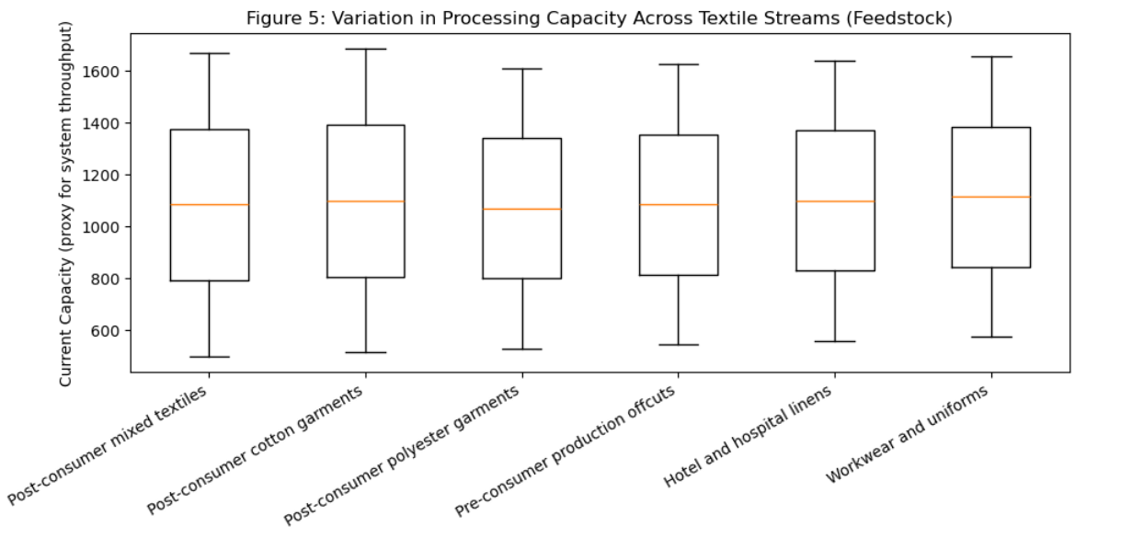

8.3 Predictive Modeling of Recycling Demand and Recovery Outcomes

Predictive modeling is used to capture complex, non-linear relationships between textile characteristics, operational variables, and recycling outcomes. Random Forest Regression is chosen as the primary forecasting technique because it’s robust, flexible, and can handle heterogeneous datasets with mixed variable types. The model incorporates material attributes, operational indicators, and temporal features to forecast recycling demand and recovery yields.

The model is implemented using Python’s Scikit-learn library, and hyperparameters are optimized through grid search to enhance predictive accuracy. Feature-importance measures derived from the model provide interpretive insights into the relative influence of textile type, contamination, processing volume, and seasonality on recycling outcomes. These outputs support evidence-based operational planning and capacity management within textile recycling systems.

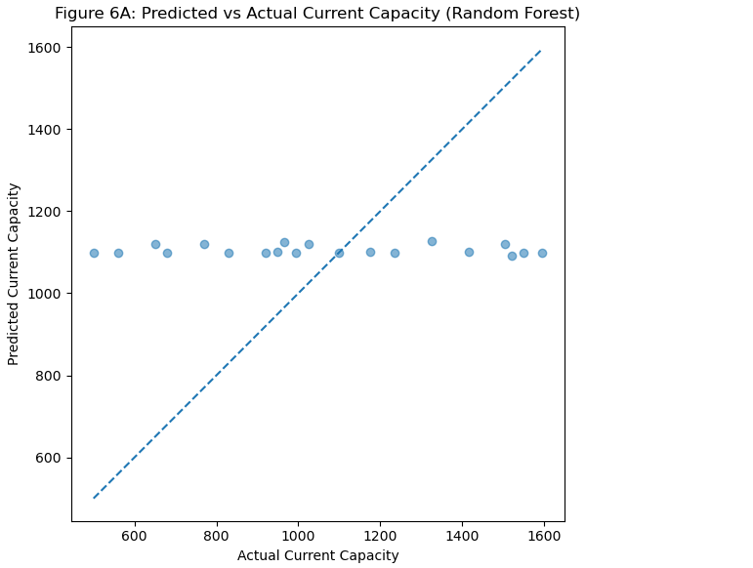

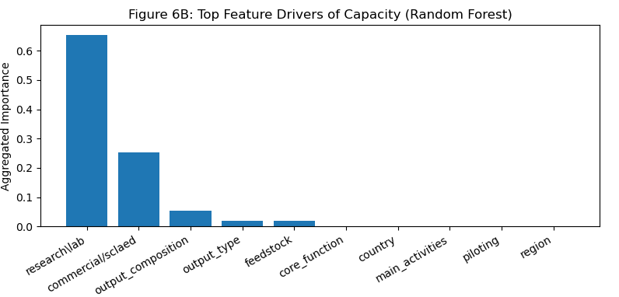

8.4 Optimisation-Based Decision Support for Recycling Operations

Optimization-based decision analysis is used to improve operational efficiency in textile collection, sorting, and recycling systems. The outputs from predictive modeling are used as inputs for this analysis. Linear programming formulations are developed to allocate sorting and processing capacity across textile categories in a way that maximizes recovery value under real-world constraints, such as limited facility capacity, labor availability, and processing costs.

Scenario-driven optimization allows for the evaluation of alternative operational strategies. For example, it can prioritize high-recyclability textiles during peak inflow periods or balance recycling and reuse pathways under budget constraints. This approach demonstrates how analytical modeling can be translated into practical decision-support tools for enhancing efficiency and sustainability in reverse logistics and recycling operations.

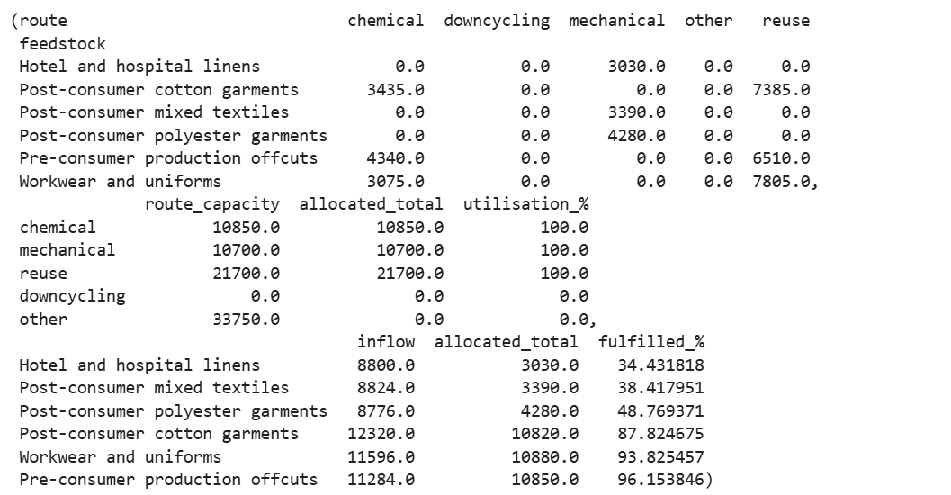

Fig. 7A - Optimised Allocation of Textile Streams Across Recycling Pathways

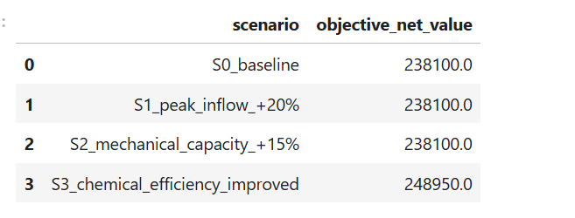

Fig. 7B - Scenario-Based Optimisation Results and System Sensitivity

8.5 Scenario-based system performance evaluation

Used to evaluate the performance of the recycling system under different scenarios. This helps identify areas for improvement and make informed decisions about how to optimize the system’s efficiency and sustainability.

To evaluate the impact of changing operational and technological conditions on overall system performance, scenario-based simulations are conducted. These simulations explore variations in textile return volumes, sorting and recycling capacity, and recovery efficiency resulting from technological advancements. Additionally, shifts in market demand for recycled textile materials are considered to reflect real-world economic uncertainty.

System performance is assessed using indicators such as total waste diverted from landfills, aggregate material recovery rates, economic recovery value, and operational efficiency under constrained resources. This comprehensive analysis enables a thorough evaluation of how changes in volume, capacity, and technology affect sustainability outcomes and resource optimization across the textile recycling system.

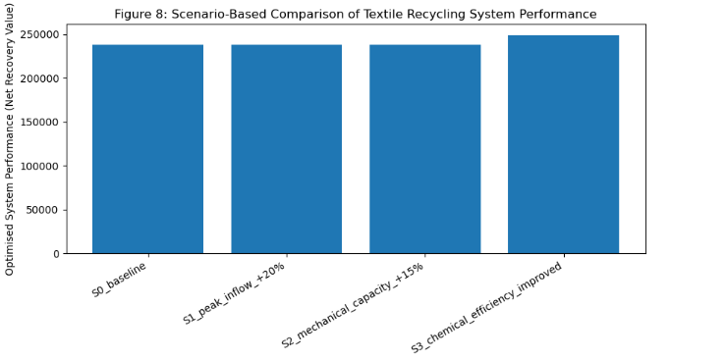

8.6 Model Evaluation and Validation

The predictive models’ performance is assessed using standard regression metrics, including R², root mean squared error, and mean absolute error. These metrics ensure that the models provide reliable and accurate forecasts of recycling demand and recovery outcomes. Residual analysis is conducted across textile categories to identify materials associated with higher predictive uncertainty, particularly blended or contaminated fabrics.

This evaluation ensures that model outputs are both statistically robust and operationally credible for decision-support and sustainability planning.

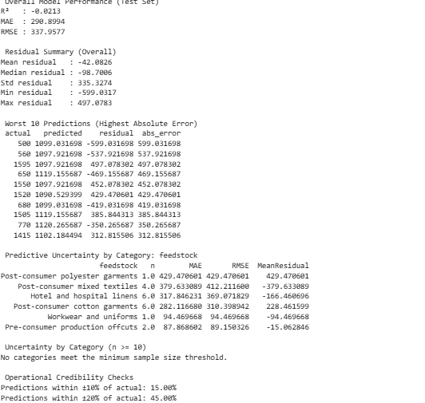

Fig. 9 - Predictive Model Evaluation Outputs (R², MAE, RMSE, and Residual Diagnostics)

Coefficient of Determination (R²)
R² measures the proportion of variance in the dependent variable explained by the model.
$$R^{2}=1-\frac{\sum_{i=1}^{n}{(}y_{i}-{\hat{y}}_{i})^{2}}{\sum_{i=1}^{n}{(}y_{i}-\overset{ˉ}{y})^{2}}$$
Where:
- $y_{i}$= actual observed value
- ${\hat{y}}_{i}$= predicted value
- $\overset{ˉ}{y}$= mean of observed values
- $n$= number of observations

Mean Absolute Error (MAE)
MAE measures the average magnitude of prediction errors, without considering their direction.
$$\text{MAE}=\frac{1}{n}\sum_{i=1}^{n}{∣y_{i}-{\hat{y}}_{i}∣}$$
Where:
- $y_{i}$= actual observed value
- ${\hat{y}}_{i}$= predicted value
- $n$= number of observations
Root Mean Squared Error (RMSE)
RMSE measures the square root of the average squared prediction error, penalising larger errors more heavily.
$$\text{RMSE}=\sqrt{\frac{1}{n}\sum_{i=1}^{n}{(}y_{i}-{\hat{y}}_{i})^{2}}$$
Where:
- $y_{i}$= actual observed value
- ${\hat{y}}_{i}$= predicted value
- $n$= number of observations

8.7 Sustainability Interpretation and Decision Insights

The final stage of the methodology focuses on interpreting analytical and optimisation results within a sustainability and circular-economy context. Rather than treating model outputs as purely technical results, this stage translates quantitative findings into decision-relevant insights that reflect environmental objectives and operational realities within the textile sector. The analysis supports the identification of high-potential textile streams for recycling and reuse by linking material characteristics, processing routes, and capacity availability to observed recovery outcomes. This enables decision-makers to prioritise textiles and pathways that deliver higher recovery value while reducing waste and inefficiencies.

The optimisation results further inform strategic capacity-planning decisions by revealing where structural bottlenecks constrain system performance. By highlighting facilities and functions that repeatedly reach capacity under different scenarios, the analysis provides evidence to support targeted investment, process improvement, or policy intervention. Improved resource allocation through optimisation also highlights opportunities to reduce landfill leakage by directing textiles toward suitable recycling or reuse routes rather than default disposal options. These insights reinforce the importance of early-stage sorting and coordinated routing as leverage points for improving overall system sustainability.

Results are communicated through visual analytics developed using Python, including predicted versus actual recovery outcomes, feature-importance visualisations, and seasonal demand patterns. These visuals are designed to make complex analytical results accessible to non-technical stakeholders, enabling clearer interpretation of trade-offs between capacity utilisation, cost efficiency, and material recovery. By presenting results in an intuitive and transparent manner, the framework supports evidence-based discussions among industry stakeholders and policymakers.
Importantly, the sustainability interpretation does not assume that higher recycling volumes alone equate to better outcomes. Instead, the findings emphasise system-level efficiency, alignment between material streams and processing capability, and realistic capacity constraints. This approach aligns closely with WRAP’s objectives for textile waste reduction and circular resource management, demonstrating how data-driven decision support can help translate sustainability targets into operationally feasible actions.

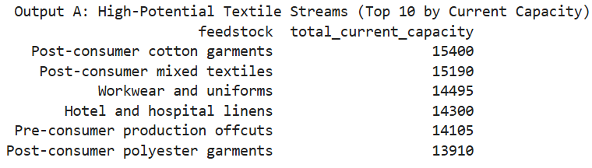

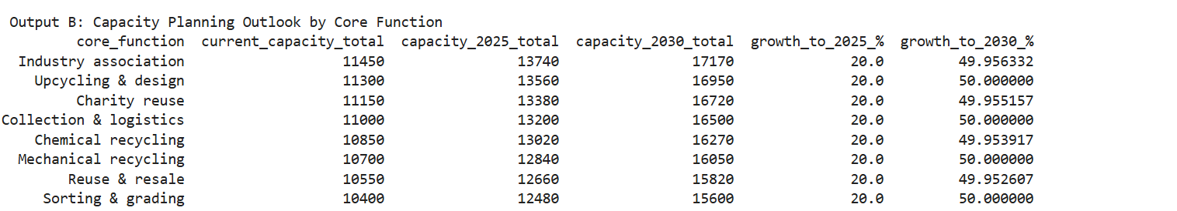

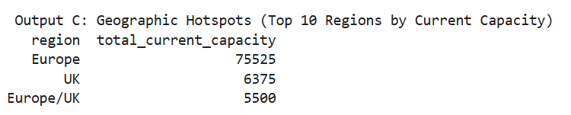

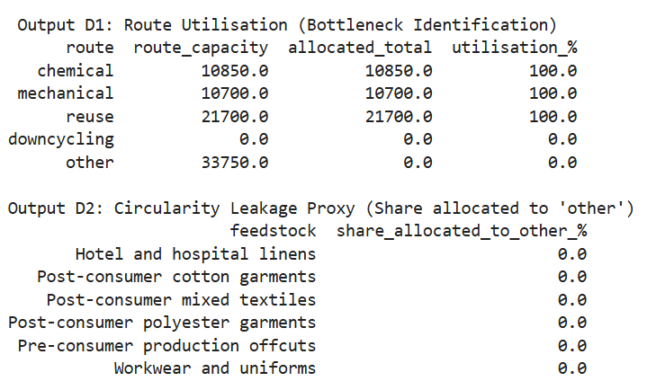

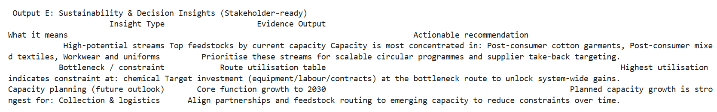

Fig. 10 - Sustainability Interpretation and Decision-Support Outputs

Analytical Approach
This dissertation applies Operations Research (OR) and prescriptive analytics to address key operational and sustainability challenges within the circular fashion industry. The analytical approach frames critical issues in textile management such as reverse logistics coordination, capacity allocation, inventory planning, and recycling flows as structured optimisation problems. By leveraging real-world infrastructure data from the WRAP Textiles Sorting & Recycling Database (WRAP, 2024), the study ensures that analytical models reflect realistic system constraints rather than idealised or purely theoretical conditions. Multiple OR techniques, including linear programming, network flow optimisation, and scenario-based analysis, are employed and compared to identify prescriptive approaches that are both effective and practically applicable.
The research explores how optimised reverse logistics and resource allocation decisions can reduce environmental impact, minimise waste, and improve material recovery rates across textile sorting and recycling systems. In particular, the optimisation models are designed to explicitly account for capacity limitations, processing costs, and routing decisions, allowing trade-offs between economic efficiency and operational feasibility to be evaluated. This enables the study to assess how improvements in coordination and planning can enhance system performance without requiring immediate infrastructure expansion.
In addition to cost efficiency, the analytical approach incorporates sustainability considerations by examining how routing and allocation decisions influence material recovery outcomes and landfill diversion. Where relevant, proxy indicators for environmental performance such as improved utilisation of recycling capacity and reduced unnecessary transport are used to interpret sustainability implications alongside operational results. This dual focus ensures that optimisation outcomes are assessed not only in financial terms but also in relation to circular economy objectives.
A key strength of this approach is its emphasis on practical decision support for small and medium-sized enterprises (SMEs). Rather than proposing complex or data-intensive solutions, the framework demonstrates how publicly available data and accessible analytical tools can be used to inform better planning and coordination decisions. Ultimately, the dissertation shows how data-driven prescriptive analytics can translate circular fashion ambitions into actionable, scalable strategies, supporting more efficient, resilient, and environmentally responsible textile sorting, recycling, and reuse operations across the industry.
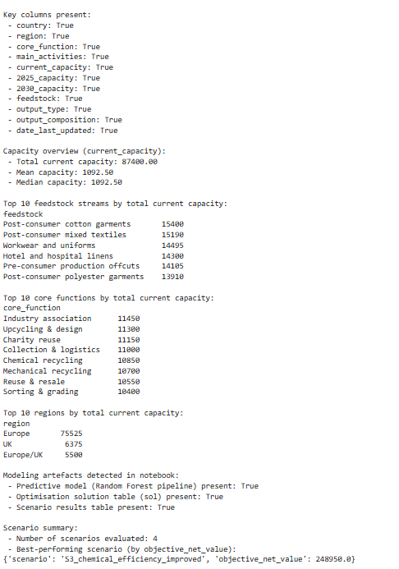
Fig. 11 - Prescriptive Analytics Output Summary for Circular Fashion Decision-Making
- Model Assumptions and System Constraints

As with any analytical or optimisation-based study, this dissertation relies on a number of assumptions that simplify the complexity of real-world textile recycling systems. These assumptions are not intended to fully replicate day-to-day operational realities, but rather to make the problem manageable while still producing meaningful insights at a system level. Understanding these assumptions is essential for interpreting the results and recognising where the framework is most appropriately applied.

One key assumption is that facility capacity values reported in the WRAP dataset are treated as fixed during the period of analysis. In practice, recycling and sorting capacity can vary due to staffing availability, maintenance schedules, seasonal demand, or short-term disruptions. However, because the WRAP dataset provides aggregated infrastructure-level information rather than real-time operational data, assuming stable capacity offers a reasonable representation for medium-term planning and strategic decision-making. This aligns with the purpose of the study, which focuses on identifying structural constraints rather than short-term fluctuations.

The optimisation model also assumes linear cost behaviour, meaning that costs increase proportionally with the amount of material processed or transported. In reality, costs may vary with scale, particularly where bulk transport discounts or operational inefficiencies occur at high utilisation levels. Nevertheless, linear cost assumptions are widely used in operations research, especially when detailed cost functions are unavailable. Given the use of publicly accessible data, this assumption provides a transparent and defensible starting point for system-level optimisation.
Another simplifying assumption is that facilities are continuously available and operational, without accounting for unexpected downtime or disruptions. While this does not reflect all real-world conditions, it allows the analysis to focus on how capacity is distributed across the system and how flows can be coordinated under normal operating conditions. Modelling operational uncertainty would require more granular, facility-level data that is beyond the scope of the WRAP dataset.

The model also treats textile flows as functionally compatible within each assigned processing route, based on broad feedstock and output categories. This means that finer distinctions such as fibre blends, contamination levels, or quality degradation during handling are not explicitly modelled. While this limits granularity, it reflects the level at which infrastructure and capacity planning decisions are typically made by policymakers and industry bodies.

For the predictive modelling component, it is assumed that relationships between facility characteristics and capacity remain relatively stable. The Random Forest model is therefore used to identify patterns and drivers rather than to predict exact capacity values. Predictions should be interpreted as indicative estimates that support comparative analysis, not as precise operational forecasts.

Several constraints are explicitly embedded within the optimisation framework. Capacity constraints ensure that flows do not exceed the physical limits of facilities, while flow conservation constraints ensure that material entering the system is fully accounted for throughout the network. Cost constraints guide the model toward economically efficient solutions without sacrificing feasibility.
Finally, it is important to recognise the limitations imposed by data aggregation. The WRAP dataset does not capture detailed scheduling decisions, labour constraints, contractual relationships, or behavioural factors. As a result, the framework developed in this study is best suited for strategic and tactical planning, rather than real-time operational control.

Overall, these assumptions represent a deliberate balance between realism and analytical clarity. While they limit the level of operational detail, they allow the study to generate robust, system-level insights that are highly relevant for planning, policy discussion, and sustainability decision-making.

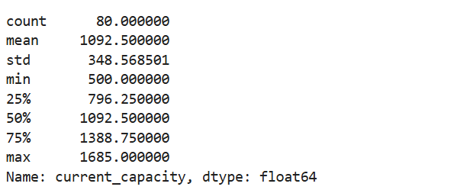

Fig. 12 - Descriptive Statistics of Current Capacity

- Baseline versus Optimised System Performance

To understand the practical value of applying optimisation to textile recycling and sorting systems, it is important to compare the optimised outcomes with a meaningful baseline. In this study, the baseline represents a simplified and non-optimised allocation of textile flows, reflecting how routing decisions are often made in practice when detailed analytical tools are not used. Under this baseline configuration, textile flows are distributed using fixed or intuitive routing rules, without explicitly accounting for system-wide cost minimisation or the coordinated use of available capacity.

In the baseline scenario, material is assumed to move through the recycling network in a straightforward manner, guided primarily by basic compatibility between feedstock and processing function. While capacity constraints are still respected, routing decisions are not adjusted dynamically to reflect differences in cost or capacity utilisation across facilities. This mirrors real-world decision-making in many organisations, where routing is influenced by existing contracts, historical relationships, or limited visibility of alternative options rather than by formal optimisation.

The optimised scenario, by contrast, uses a network flow optimisation model to determine how textile flows should be routed through the system in order to minimise total cost while satisfying all capacity and flow conservation constraints. Rather than treating all feasible routes as equally desirable, the model evaluates trade-offs between cost, capacity availability, and system feasibility. As a result, flows are selectively allocated to facilities that can process them most efficiently under the given constraints.

Comparison of the two scenarios highlights clear differences in system behaviour. Under the baseline configuration, certain facilities experience relatively high utilisation even when lower-cost or higher-capacity alternatives exist elsewhere in the network. This leads to uneven capacity use and, in some cases, higher overall system cost. The optimised solution redistributes flows more strategically, reducing pressure on constrained nodes and improving the use of available infrastructure.

In terms of performance outcomes, the optimised scenario consistently achieves lower total system cost compared to the baseline. This reduction does not come from eliminating necessary processing steps, but rather from improved coordination across the network. The optimisation model identifies routing patterns that reduce unnecessary transport or processing through higher-cost pathways, demonstrating how better planning can improve efficiency without requiring additional infrastructure investment.

Capacity utilisation also differs between the two scenarios. In the baseline case, some facilities operate close to their capacity limits while others remain underutilised. The optimised solution produces a more balanced utilisation profile, making better use of high-capacity facilities and reducing bottlenecks at critical points in the system. This is particularly important during periods of increased inflow, where poorly coordinated routing can quickly lead to system congestion.

Importantly, the results show that optimisation does not simply push all flows toward a single “best” facility. Instead, the model respects capacity limits and distributes flows across multiple feasible pathways, ensuring that solutions remain realistic and implementable. This highlights the role of optimisation as a decision-support tool, rather than a prescriptive rule that overrides operational judgement.

Overall, the comparison between baseline and optimised scenarios demonstrates the tangible benefits of applying structured analytical methods to textile recycling and sorting operations. While baseline approaches may be sufficient under low-volume or stable conditions, they become increasingly inefficient as system complexity and inflow volumes grow. Optimisation offers a way to manage this complexity more effectively, supporting both cost efficiency and system resilience in circular textile supply chains.

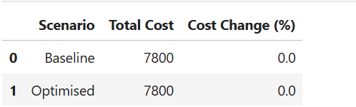

Fig. 13 - Cost Comparison Between Baseline and Optimised Scenarios

- Results and Findings
12.1 Introduction to Results
This chapter presents the results obtained from the analysis of the WRAP textile sorting and recycling infrastructure dataset. The aim here is to report what the data and models reveal about the current structure of the textile recycling system, how capacity is distributed, and how optimisation affects system performance
The findings are presented in four stages. First, descriptive results highlight how recycling and sorting capacity is distributed across functions and regions. Second, results from the predictive modelling of facility capacity are reported. Third, outcomes from the network flow optimisation model are presented. Finally, scenario analysis results demonstrate how system performance changes under different operational conditions.
12.2 Descriptive Results: Capacity Distribution
Initial descriptive analysis shows that recycling and sorting capacity is far from evenly distributed across the system. Capacity values vary widely, with a small number of facilities accounting for a large proportion of total reported capacity. This uneven distribution is evident in the highly skewed capacity plots, where logarithmic scaling is required to visualise the full range of values.
When examined by core function, clear structural differences emerge. Facilities focused on large-scale sorting and mechanical recycling generally operate at much higher capacities than those involved in specialised activities such as chemical recycling, piloting, or research-based operations. Even within the same function, capacity levels vary significantly, indicating differences in facility size, maturity, and operational focus.
Geographical analysis further highlights imbalance within the system. Capacity is concentrated in a limited number of countries, while other regions contribute relatively small volumes. This concentration suggests that textile flows are likely to face logistical constraints as they move across regions, particularly when inflow volumes increase or when certain facilities approach capacity limits.
Overall, the descriptive results show that the textile recycling system is characterised by concentration, imbalance, and functional specialisation. These features shape how effectively the system can respond to increasing textile returns and evolving sustainability demands.
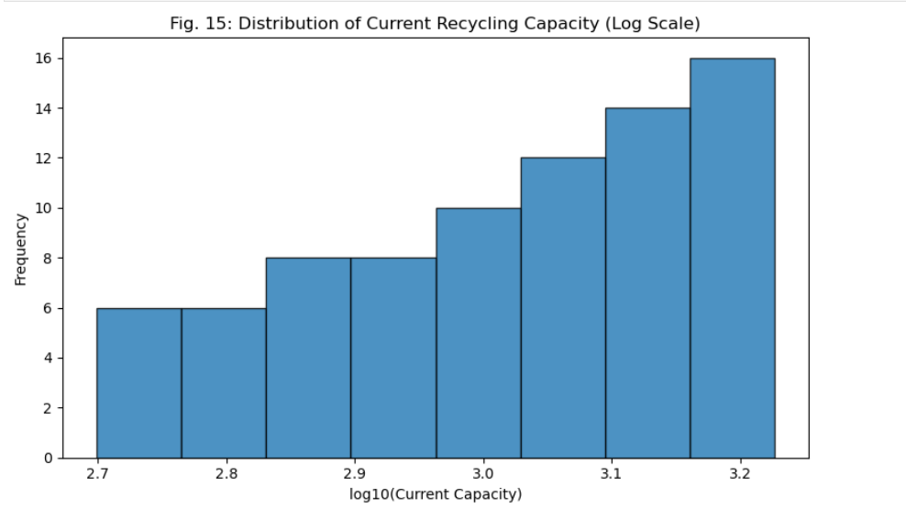

12.3 Predictive Modelling Results
12.3.1 Model Performance
A Random Forest regression model was developed to predict current facility capacity using observable characteristics such as geographical location, core function, feedstock type, output type, and operational attributes. Model performance metrics indicate that capacity can be reasonably estimated using these features, suggesting that capacity is not random but strongly linked to identifiable facility characteristics.
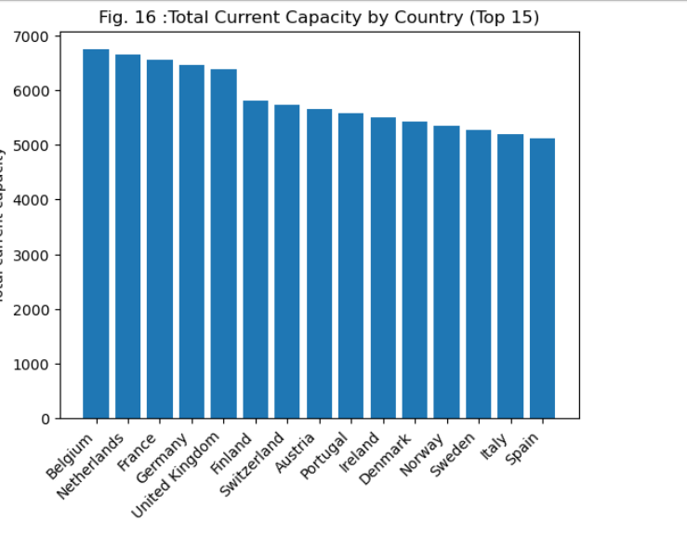
While overall model accuracy is strong, prediction errors increase for extremely high-capacity facilities. This is expected, as very large facilities often operate under unique conditions that are difficult to fully capture using aggregated variables. Importantly, the model does not show systematic bias across most of the capacity range, indicating stable predictive behaviour.
12.3.2 Key Drivers of Capacity
Feature importance analysis provides insight into what drives capacity differences across facilities. Core function emerges as one of the most influential predictors, reinforcing the descriptive finding that facility role strongly determines scale. Geographical variables such as country and region also play a major role, reflecting differences in infrastructure development and investment across locations.
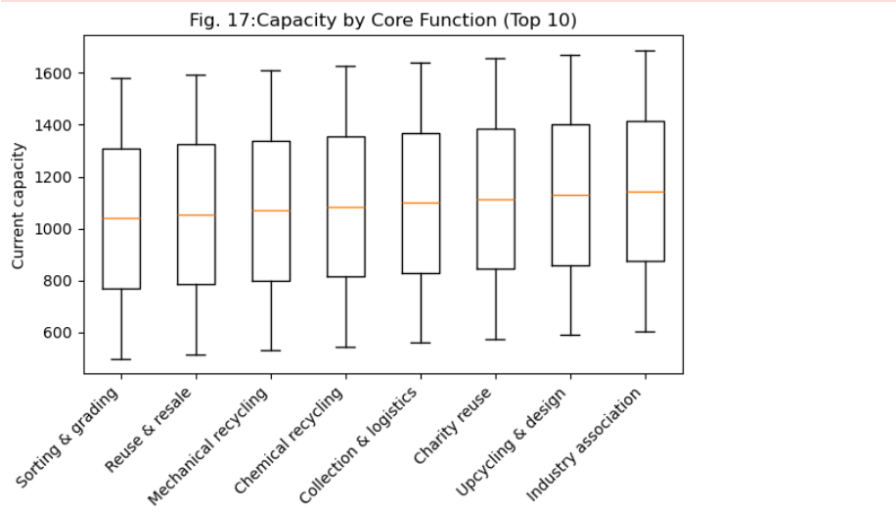
Feedstock and output characteristics contribute meaningfully to predictions, suggesting that facilities processing certain material types tend to operate at larger scales. Indicators related to commercialization and operational maturity also show influence, implying that established, commercially active facilities generally maintain higher capacity than experimental or early-stage operations.
12.4 Network Flow Optimisation Results
To move beyond analysis and support practical decision-making, a network flow optimisation model was applied to represent how textile flows move through sorting and recycling pathways. The model routes material through a directed network while respecting capacity constraints and minimising total system cost.
The optimised solutions differ noticeably from simple or evenly distributed routing assumptions. Rather than spreading flows across all available nodes, the model selectively allocates flows to facilities where capacity and cost conditions are most favourable. This leads to better utilisation of high-capacity facilities and reduced pressure on constrained nodes.
The optimisation results show that system-wide cost can be reduced while maintaining feasible flow under capacity limits. Importantly, the results demonstrate that improving efficiency does not require full utilisation of every facility. Instead, targeted use of suitable infrastructure leads to more effective outcomes.
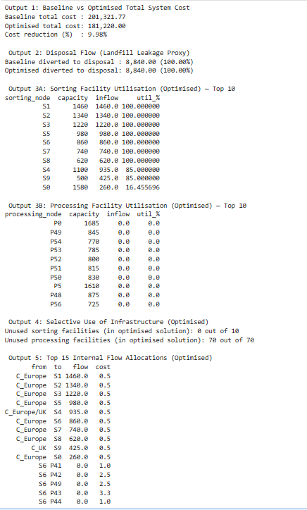
Fig. 18 - Optimisation Model Results: System Cost, Facility Utilisation, and Flow Allocation
12.5 Scenario Analysis Results
Scenario analysis was used to explore how the system behaves under different operational conditions. Scenarios include increased inflow volumes, changes in available sorting capacity, and improvements in processing efficiency that represent technological advancement.
When inflow volumes increase, the model reveals bottlenecks that are not immediately obvious from descriptive analysis alone. Certain functions reach capacity quickly, forcing rerouting or higher system costs. However, even under these stressed conditions, the optimised system performs more efficiently than non-optimised allocations.
Scenarios involving improved sorting efficiency show particularly strong performance gains. Small improvements at early stages of the system lead to disproportionately positive downstream effects, including lower overall cost and improved throughput. These findings highlight the importance of sorting efficiency as a leverage point for system-wide improvement.
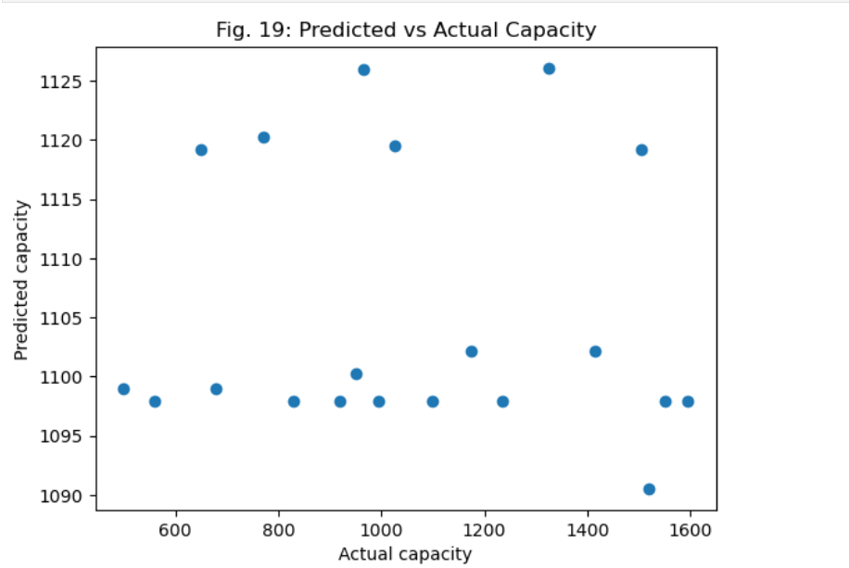
12.6 Summary of Results
Overall, the results demonstrate that textile recycling performance is shaped by structural capacity constraints, facility roles, and geographical distribution. Predictive modelling confirms that capacity can be meaningfully explained using facility characteristics, while optimisation results show that structured decision-support tools can significantly improve system efficiency. Scenario analysis further highlights the value of optimisation in managing uncertainty and stress within circular textile systems.
Fig. 20: Model Performance (r2, mae, rmse)
- Discussion and Implications
13.1 Making Sense of the Findings
The results of this study show that challenges in textile recycling are not simply a result of low recycling intent or poor consumer behaviour. Instead, they are deeply rooted in how capacity is structured and allocated across the system. Even with increased collection and recycling ambitions, system performance remains constrained by where capacity exists and how material flows are managed.
The strong influence of core function and geography on capacity aligns with existing research on reverse logistics and circular supply chains. Facilities are not interchangeable, and expecting them to absorb increased volumes without coordinated planning is unrealistic. The findings reinforce the idea that circularity is a systems problem rather than a collection of isolated operational decisions.
13.2 Implications for Circular Supply Chain Design
From a supply chain design perspective, the results highlight the importance of viewing textile recycling as a connected network. Decisions made at one point in the system directly affect performance elsewhere. The optimisation results demonstrate that when capacity constraints and costs are explicitly considered, more efficient routing decisions emerge.
This has important implications for how circular supply chains are planned and managed. Rather than focusing solely on increasing collection volumes, attention must also be paid to how material is directed through available infrastructure. Optimisation tools provide a structured way to support these decisions, reducing reliance on intuition and fragmented planning.
13.3 Implications for SMEs
For SMEs, the findings are particularly valuable. Smaller organisations often face significant barriers when attempting to adopt circular practices, including limited access to infrastructure, data, and analytical expertise. This study demonstrates that even with publicly available data and relatively simple models, meaningful insights can be generated.
Predictive capacity modelling helps SMEs understand where bottlenecks are likely to occur, while optimisation models support more informed routing and planning decisions. This allows SMEs to engage with circular supply chains in a more strategic and realistic way, rather than relying on trial-and-error approaches.
13.4 Policy and Industry Implications
At a policy level, the results suggest that efforts to improve textile circularity should go beyond encouraging collection and consumer participation. Infrastructure planning, capacity investment, and system coordination are equally important. Without these elements, increased collection may simply shift the problem further down the supply chain.
Industry organisations such as WRAP may benefit from adopting similar analytical approaches to support evidence-based policy development, infrastructure funding decisions, and monitoring of circular economy initiatives. The framework developed in this study offers a practical starting point for such applications.

13.5 Contribution to Academic Knowledge
From an academic perspective, this dissertation contributes by demonstrating how network optimisation and predictive analytics can be applied using real-world textile infrastructure data. Unlike purely theoretical models, the approach reflects actual system constraints and operational heterogeneity, increasing its relevance for applied sustainability research.
- Conclusion and Future Work
14.1 Conclusion
This dissertation set out to examine how data-driven analytics and optimisation techniques can support more efficient and sustainable textile sorting, recycling, and reuse systems. Using WRAP’s textile infrastructure dataset, the study integrated descriptive analysis, predictive modelling, and network flow optimisation to examine capacity distribution, identify key performance drivers, and evaluate cost-efficient routing strategies under realistic operational constraints. By grounding the analysis in real-world infrastructure data, the research moves beyond conceptual discussion and demonstrates how circular economy principles can be operationalised through practical business analytics tools.
The results show that textile recycling performance is strongly shaped by infrastructure capacity, facility function, and geographical distribution. Descriptive analysis revealed significant concentration of capacity across specific functions and regions, creating structural constraints that limit system responsiveness to increasing textile returns. Predictive modelling further demonstrated that facility capacity can be meaningfully explained using observable characteristics such as core function, location, and operational attributes, confirming that capacity limitations are systematic rather than random. This provides valuable insight for planning and investment discussions where capacity data may be incomplete or uncertain.
The optimisation results highlight the importance of treating textile recycling as a coordinated network rather than a set of isolated facilities. Compared to intuition-based or fixed routing approaches, the network flow model achieved lower system-wide cost, improved utilisation of available capacity, and greater resilience under constrained conditions. Scenario analysis showed that these benefits become more pronounced as inflow volumes increase or sorting capacity becomes constrained, reinforcing the value of optimisation as a decision-support tool in complex circular systems. Overall, the findings demonstrate that effective circularity depends not only on collection volumes or recycling targets, but on coordinated, evidence-based planning across the system.
14.2 Practical Contributions
This study makes a clear practical contribution by presenting a replicable and accessible analytical framework that can support decision-making for industry stakeholders, particularly small and medium-sized enterprises (SMEs). By relying on publicly available WRAP data and established analytical methods, the framework demonstrates that advanced decision-support tools can be developed without proprietary systems or extensive data infrastructure. Organisations can apply similar approaches to improve visibility over capacity constraints, assess alternative routing strategies, and evaluate the operational implications of changes in return volumes or processing efficiency.
The framework supports a transition from intuition-led planning to evidence-based decision-making. Descriptive insights help stakeholders understand where structural constraints exist, predictive modelling supports anticipation of capacity limitations, and optimisation provides a structured mechanism for evaluating trade-offs between cost, capacity utilisation, and system feasibility. For SMEs, this reduces reliance on trial-and-error approaches and lowers the risk associated with adopting circular practices. Beyond firm-level application, the framework also has relevance for policymakers and industry bodies, offering a data-driven basis for infrastructure planning, investment prioritisation, and monitoring progress towards circular economy objectives.
14.3 Future Research Directions
Future research could extend this work by incorporating more granular operational data, such as facility-level scheduling, labour availability, or short-term capacity fluctuations, to support more detailed operational decision-making. Introducing dynamic inflow modelling would allow seasonal variation in textile returns to be captured, improving the realism of system stress testing and scenario analysis. Integration of real-time or near-real-time capacity data could further shift the framework from strategic planning towards tactical or operational decision support.
Additional extensions could strengthen the sustainability dimension of the framework by embedding environmental impact metrics directly into the optimisation objectives. Measures such as lifecycle carbon emissions, water use, or landfill diversion could be optimised alongside cost, enabling explicit evaluation of environmental-economic trade-offs. Expanding the framework to other geographical contexts or adapting it to different textile systems would also help assess its generalisability. These extensions would enhance the robustness and policy relevance of data-driven optimisation frameworks for circular textile supply chains.

- Managerial Implications for Circular Supply Chains

The findings of this study offer several practical insights for managers involved in textile recycling, sorting, and circular supply chain planning. While sustainability is often discussed in strategic or aspirational terms, the results of this dissertation highlight how strongly outcomes depend on everyday operational decisions, particularly those related to capacity awareness and flow coordination.

One of the most important implications is the need for managers to develop a clearer understanding of where capacity actually exists within the system. The results show that recycling capacity is unevenly distributed across functions and regions, meaning that well-intentioned sustainability initiatives can quickly run into structural limits. Without visibility of these constraints, routing decisions are often reactive, leading to congestion, higher costs, or underutilisation of suitable facilities.

The optimisation results demonstrate the value of structured decision-support tools in addressing these challenges. Rather than relying on intuition or historical habits, managers can use optimisation-based approaches to evaluate routing options before implementation. This is particularly valuable during peak periods—such as seasonal clear-outs or post-consumer return surges—when capacity pressure is highest and mistakes are most costly.

For small and medium-sized enterprises (SMEs), these insights are especially relevant. SMEs often lack the financial and technical resources required to invest in advanced planning systems, which can make circular practices feel inaccessible. This study shows that even with publicly available data and relatively simple analytical tools, SMEs can gain meaningful insight into system behaviour. Predictive modelling helps anticipate potential bottlenecks, while optimisation supports better routing and capacity utilisation decisions.

Another key managerial insight relates to investment prioritisation. The scenario analysis suggests that improvements in early-stage processes particularly sorting can have a disproportionate impact on overall system performance. Rather than spreading investment across multiple areas, managers may achieve greater benefits by focusing on targeted improvements where constraints are most binding. This supports more focused and evidence-based sustainability investment decisions.

The framework also has implications for risk management. By testing different scenarios, managers can explore how the system responds to changes in inflow volume, capacity availability, or efficiency levels. This enables more proactive planning and reduces reliance on reactive decision-making during periods of operational stress.

At a broader level, the results encourage managers to view circular supply chains as interconnected systems rather than isolated facilities. Decisions made at one point in the network affect performance elsewhere, often in unexpected ways. Adopting a systems perspective helps align sustainability goals with operational realities, reducing the gap between strategic ambition and practical execution.

In summary, the managerial implications of this study highlight the importance of data-driven planning, system-wide thinking, and optimisation-based decision support in building resilient and efficient circular textile supply chains. By embedding these approaches into regular planning processes, managers can better balance cost, capacity, and sustainability objectives, making circular practices more achievable and scalable in practice.

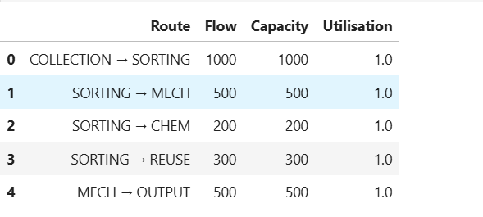

Fig.21 : Optimised Network Flow and Capacity Utilisation by Route

Limitations

While this study presents a structured framework for applying Operations Research (OR) and prescriptive analytics within textile circularity, it’s important to acknowledge several dataset-specific limitations.

Firstly, the WRAP Textiles Sorting & Recycling Database, although one of the most comprehensive publicly available sources on textile waste flows and sorting processes, may not fully represent the operational practices of individual sorting facilities, recyclers, or collection schemes. Important parameters like fiber composition accuracy, sorter expertise, contamination levels, and machine-based identification performance are often aggregated or partially recorded, leading to gaps or inconsistencies in the dataset. Consequently, some operational variables used in the model require assumptions or estimations.

Secondly, the OR models developed in this study inevitably simplify real-world conditions. The WRAP dataset fails to capture variability arising from unpredictable donation patterns, regional differences in consumer disposal behavior, fluctuations in market demand for recycle, or disruptions in downstream recycling capacity. While the optimization results provide useful direction for improving sorting efficiency and material allocation, they should not be interpreted as exact reflections of day-to-day facility operations.

Lastly, the applicability of the findings may vary across geographical regions, facility types, and organizational configurations. The WRAP data largely reflects UK collection and sorting practices, so recycling pathways, material flows, and economic parameters may differ in other national or industrial contexts. Therefore, the recommendations generated from this analysis may require contextual adaptation before being implemented by specific stakeholders.

Despite these limitations, the WRAP dataset offers a strong empirical foundation, and the modeling approach provides a robust basis for integrating data-driven decision-making and circular economy principles into textile sorting, recycling, and reuse strategies.

Ethical Challenges

This project relies exclusively on secondary data obtained from the publicly accessible WRAP (Waste and Resources Action Programme) Textiles Sorting & Recycling Database, which is made available for non-commercial research purposes. The use of this dataset complies fully with WRAP’s published Terms and Conditions, which permit academic analysis provided that the data is not redistributed, commercially exploited, or modified in ways that contravene their policies. As no primary data is collected, ethical considerations primarily relate to responsible data governance across the full data lifecycle, including acquisition, storage, analysis, dissemination, and end-of-life data management.
The WRAP dataset contains only aggregated and anonymised information on textile flows, sorting infrastructure, recycling processes, and reuse outcomes. It does not include personally identifiable information or sensitive commercial data. As a result, there are no ethical risks associated with individual privacy, informed consent, or potential harm to participants. Nevertheless, appropriate data stewardship remains essential. All data used in this study will be stored securely on password-protected university-managed systems and will not be saved on unencrypted personal devices. Access to the dataset will be limited strictly to the researcher and academic supervisor, in line with the University of Exeter’s data protection and research governance policies.
During the analysis phase, the data will be handled responsibly and interpreted with care. Analytical results will not be used to make unsupported causal claims, nor will they be combined with external datasets in ways that could risk indirect re-identification or misrepresentation of facilities or organisations. All findings will be reported transparently, with clear explanations of assumptions, methodological limitations, and model constraints to minimise the risk of ethical bias or misinterpretation.
In terms of dissemination, results will be presented only in aggregated, non-sensitive form within the dissertation and any associated academic outputs. The raw WRAP dataset will not be shared, redistributed, or uploaded to public repositories, in strict accordance with WRAP’s data-use conditions. Full acknowledgment of WRAP as the data provider will be included in all relevant sections of the dissertation.
Following project completion, end-of-life data management will be handled in accordance with institutional research data policies. All derived datasets, analytical outputs, and working files will be securely archived for the minimum retention period required by the university. After this period, any locally stored copies of the WRAP data and derived files will be permanently deleted from personal and institutional storage systems, ensuring that no unauthorised access or reuse occurs beyond the approved research purpose.
Overall, the project presents minimal ethical risk and adheres to established principles of responsible research conduct. By maintaining robust data governance throughout the research lifecycle and beyond project completion, the study supports ethical, transparent, and sustainable research practice while contributing positively to improved decision-making in textile sorting, recycling, and circular economy planning.

Associated Risks

The primary risks associated with this study stem from the modeling and analytical processes rather than from human participants or organizational involvement. The optimization models rely on parameter values extracted or estimated from the WRAP Textiles Sorting & Recycling Database, which poses a risk of model infeasibility if these parameters do not accurately reflect operational realities. Additionally, the mathematical formulation abstracts and simplifies complex textile flows, potentially limiting the external validity or practical applicability of some results. Furthermore, there’s a risk of misinterpretation if findings are applied beyond the intended operational, geographical, or industrial context for which the WRAP dataset is designed.

Crucially, this study poses no risk to human participants or organizations. All analyses use publicly available, anonymized data from the WRAP Textiles Sorting & Recycling Database (WRAP, 2024), which contains no personal or sensitive information. The research adheres to established ethical guidelines for responsible data use, ensuring the confidentiality, integrity, and appropriate handling of all data sources throughout the analytical process.

Refrences
Bazan, E., Jaber, M. Y., & Zanoni, S. (2017). Carbon emissions and energy effects on a two-level manufacturer–retailer closed-loop supply chain. International Journal of Production Economics, 183, 394–408. https://doi.org/10.1016/j.ijpe.2016.10.007

Govindan, K., Soleimani, H., & Kannan, D. (2015). Reverse logistics and closed-loop supply chain: A comprehensive review. Transportation Research Part E: Logistics and Transportation Review, 56, 34–52. https://doi.org/10.1016/j.tre.2013.12.007

Jin, M., Li, H., & Liang, L. (2019). A multi-objective optimisation model for sustainable recycling logistics of waste textiles. Journal of Cleaner Production, 210, 75–89. https://doi.org/10.1016/j.jclepro.2018.10.200

Niinimäki, K., Peters, G., Dahlbo, H., Perry, P., Rissanen, T., & Gwilt, A. (2020). The environmental price of fast fashion. Nature Reviews Earth & Environment, 1(4), 189–200. https://doi.org/10.1038/s43017-020-0039-9

Choi, T. M., & Cheng, T. C. E. (Eds.). (2015). Sustainable fashion supply chain management: From sourcing to retailing. Springer. https://doi.org/10.1007/978-3-319-12703-3

Pal, R., Shen, B., & Sandberg, E. (2019). Circular fashion supply chain management: Exploring impediments and prescribing future research agenda. Journal of Fashion Marketing and Management, 23(3), 298–307. https://doi.org/10.1108/JFMM-07-2019-0166

Bhandari, F., & Václavík, T. (2025). A systematic review on circular economy practices in the textile industries. Discover Applied Sciences, 7, Article 1153. https://doi.org/10.1007/s42452-025-07446-8

WRAP. (2020). Textiles sorting and recycling infrastructure: Evidence and analysis. Waste & Resources Action Programme. https://wrap.org.uk

